Fun Music Company Boomwhacker Educational Resources Range 2015

information for retailers

‘Play Boomwhackers’ DVD Retail $19.95

NTSC (All regions) DVD for US and Canada
PAL (All regions) for UK and Australia

UPC: 760999951119
This is a consumer DVD designed to be used by children at home or at school with a set of standard Boomwhackers. Ideal to be sold as a companion product to Rhythm Band Instruments’ diatonic Boomwhacker set.

barcode on product:

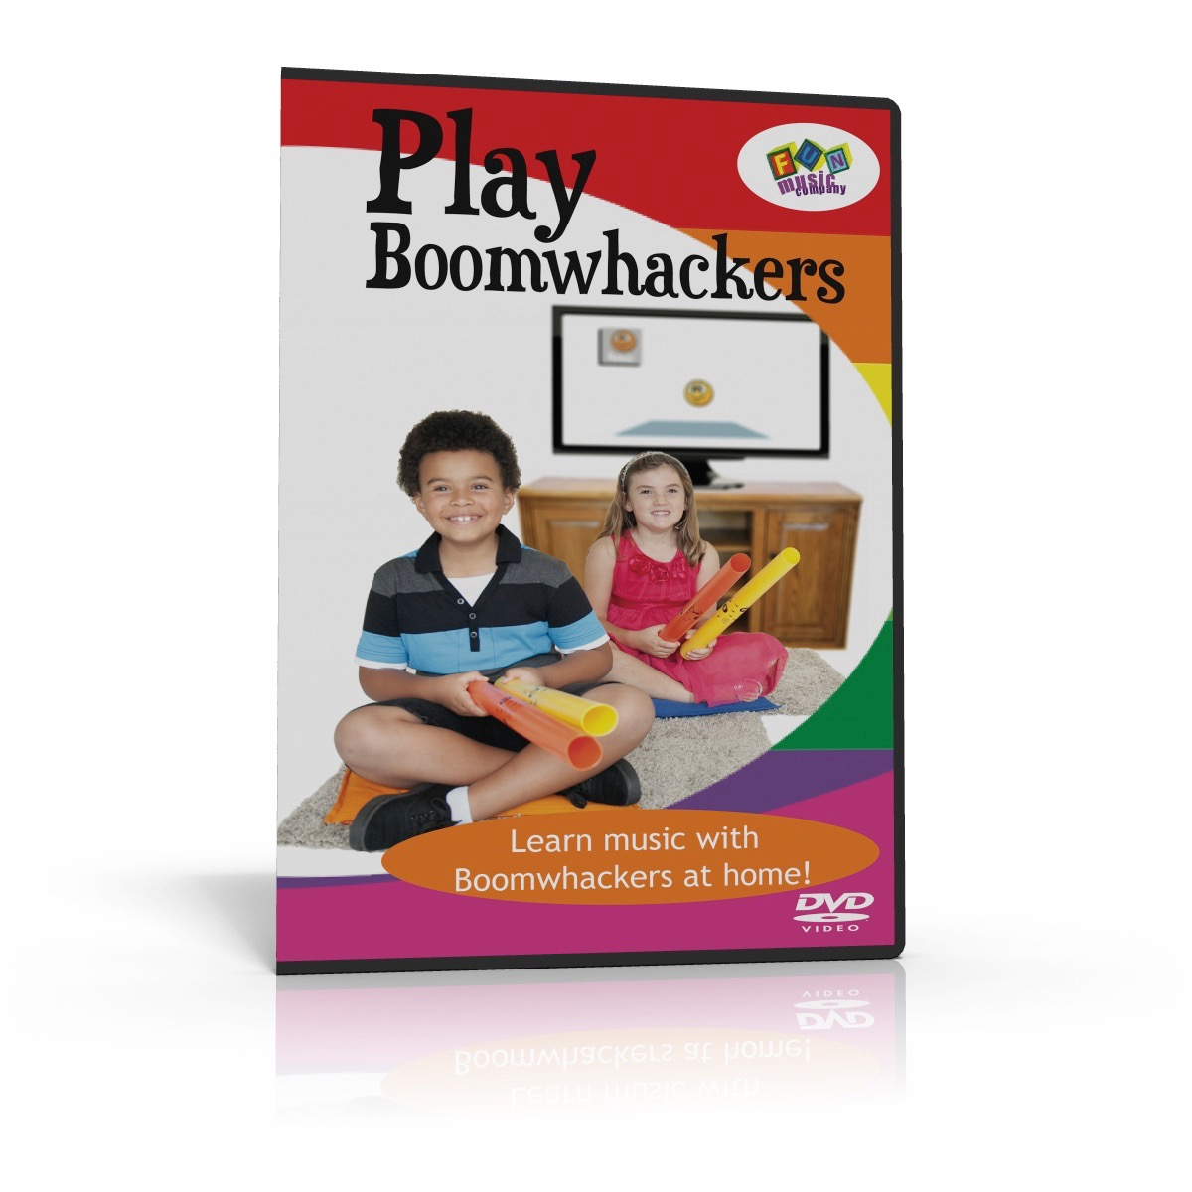
Product Artwork

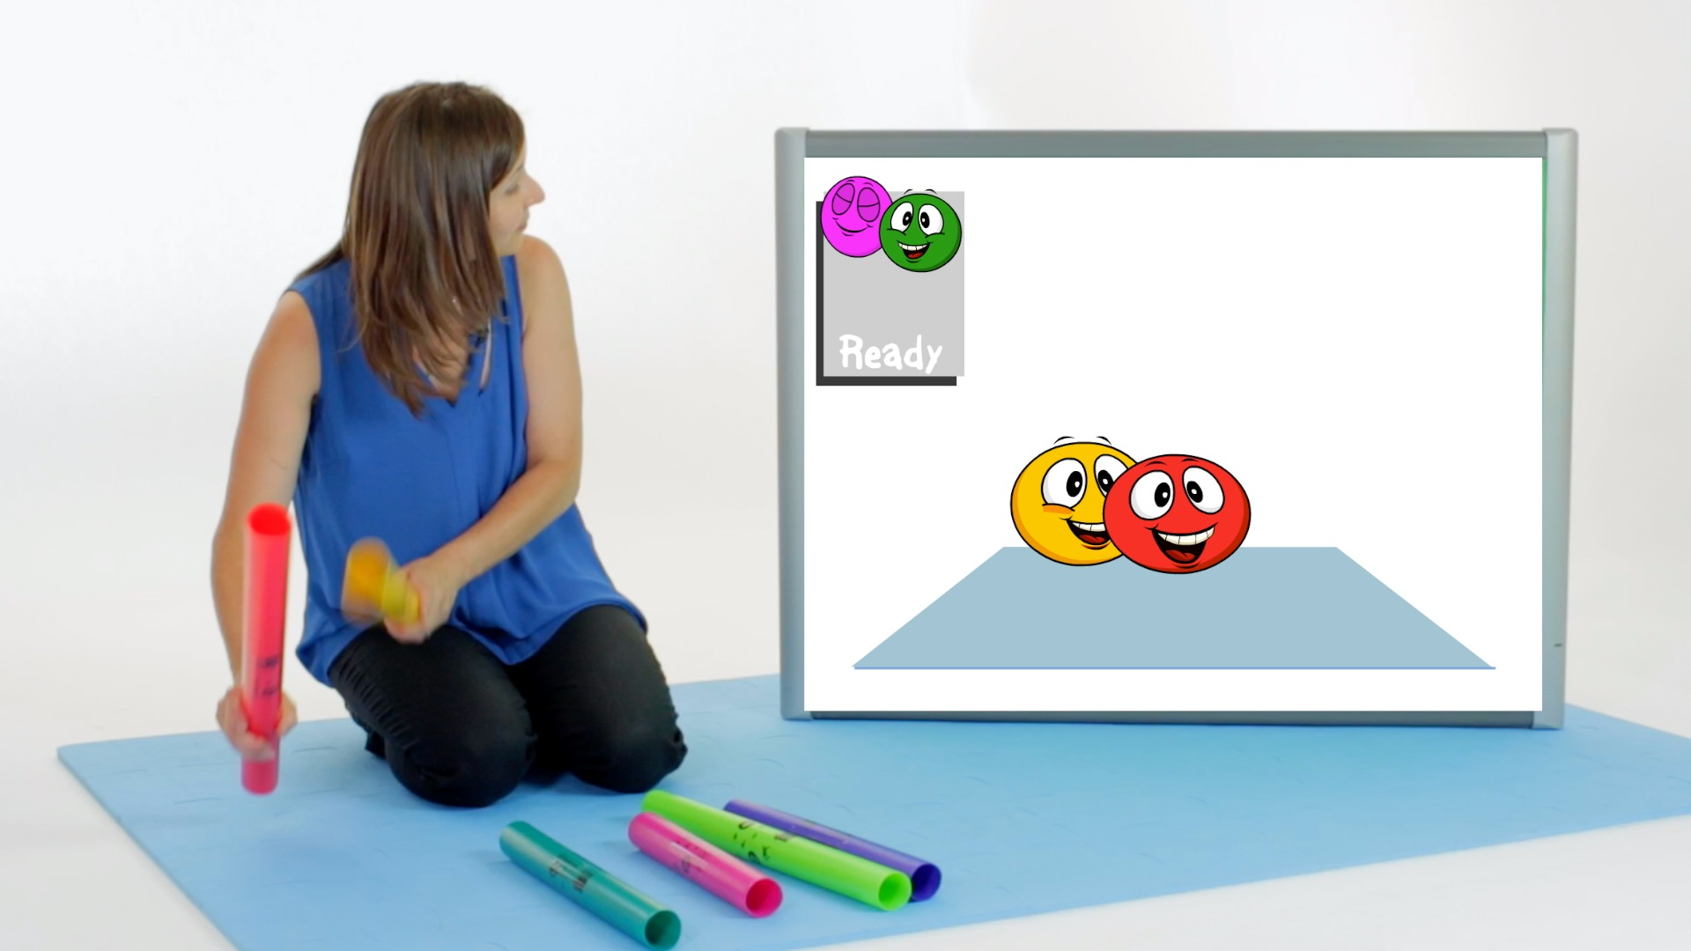
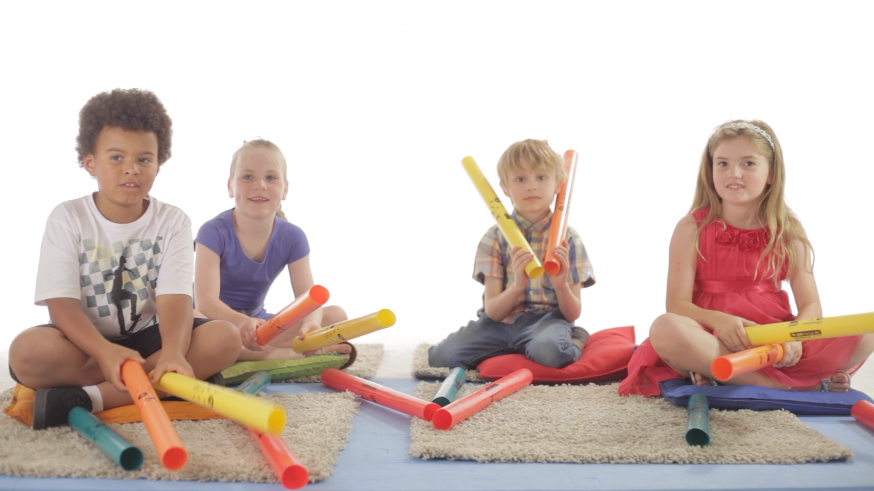
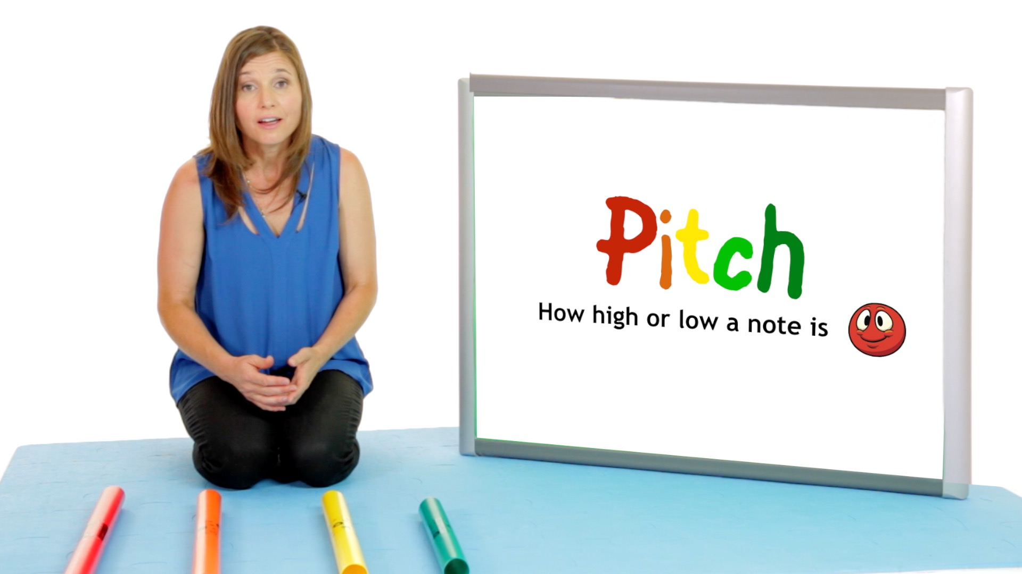
Screenshots (also available in high res .jpg included in enclosed folder)

Short Text:

A DVD for children to use at home when learning music with Boomwhacker musical tubes. Children simply watch the animations and play when the little characters bounce around. Loads of fun!

Medium Text:

Learn Boomwhackers at home! Children will have fun learning to play Boomwhackers with the ‘Boomwhacker Beatz’ characters as they jump on the screen and show the children where to play. They don’t need to read music, as they simply follow the animations and play when the ‘Beatz' bounce on the ‘Play Mat’. Music Educator Janice Tuck gently guides the children through learning about musical concepts such as pitch, rhythm and harmony, all while they are just having fun and playing in time with the animated characters.

Long Text:

Children can now learn Boomwhackers at home!

In this fun and educational DVD, experienced music educator Janice Tuck gently introduces children to music, just while they are having fun!

Boomwhacker musical tubes have been around for many years, and they are very popular in school music classrooms.
However, most people think that you have to play one tube at a time, and put together a melody, by combining your one or two notes with a few others played by your friends. Of course there is nothing wrong with this approach, but the approach in this DVD is different.
The idea here is that children get to play a whole set of Boomwhackers, and in this DVD children sit one the floor with a complete set in front of them, and change throughout the songs, and play different melodies and rhythms with them.
They don’t need to read music, as they simply follow the animations and play when the colourful ‘Beatz' characters bounce on the ‘Play Mat’.

Of course we don’t start with all eight Boomwhackers at once - they gently go through a process of building up from one, to two, then four, six and eight Boomwhackers all in the same song.

Children will learn important musical concepts such as pitch, rhythm and harmony, all while they are just having fun and playing in time with the animated characters.

‘Boomwhacker Beatz’ Songs and Games Retail $39.95

Software CD-ROM for PC and Mac.

UPC: 760999951133

Barcode on product:
This is a software CD-ROM designed for use in elementary schools.
Compatible with PC or Mac.

Please note: This CD contains much of the same content as ‘Boomwhacker Beatz Curriculum edition’, but without the customisable content and detailed lesson plans. Customers should choose ONE of ‘Songs and games edition’ OR ‘Curriculum edition’

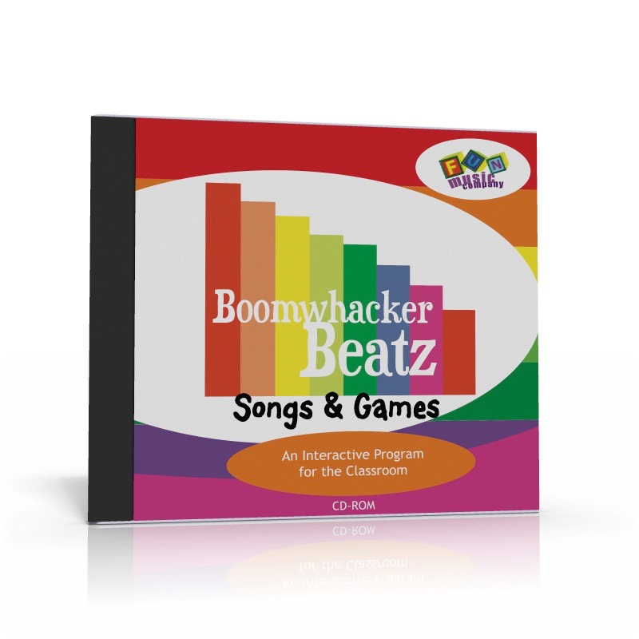
Product Artwork:
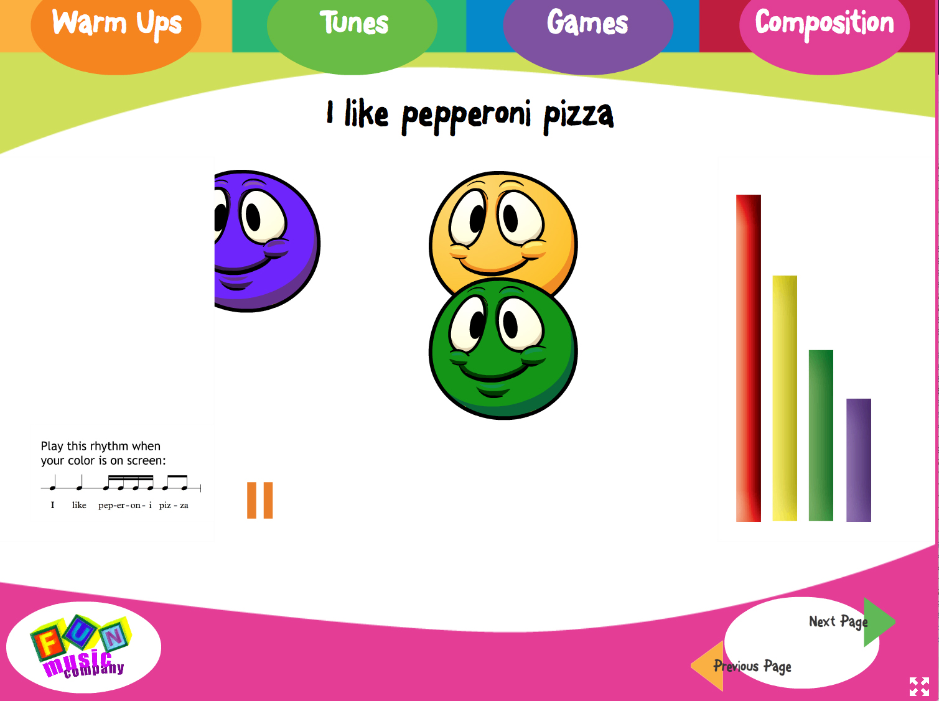
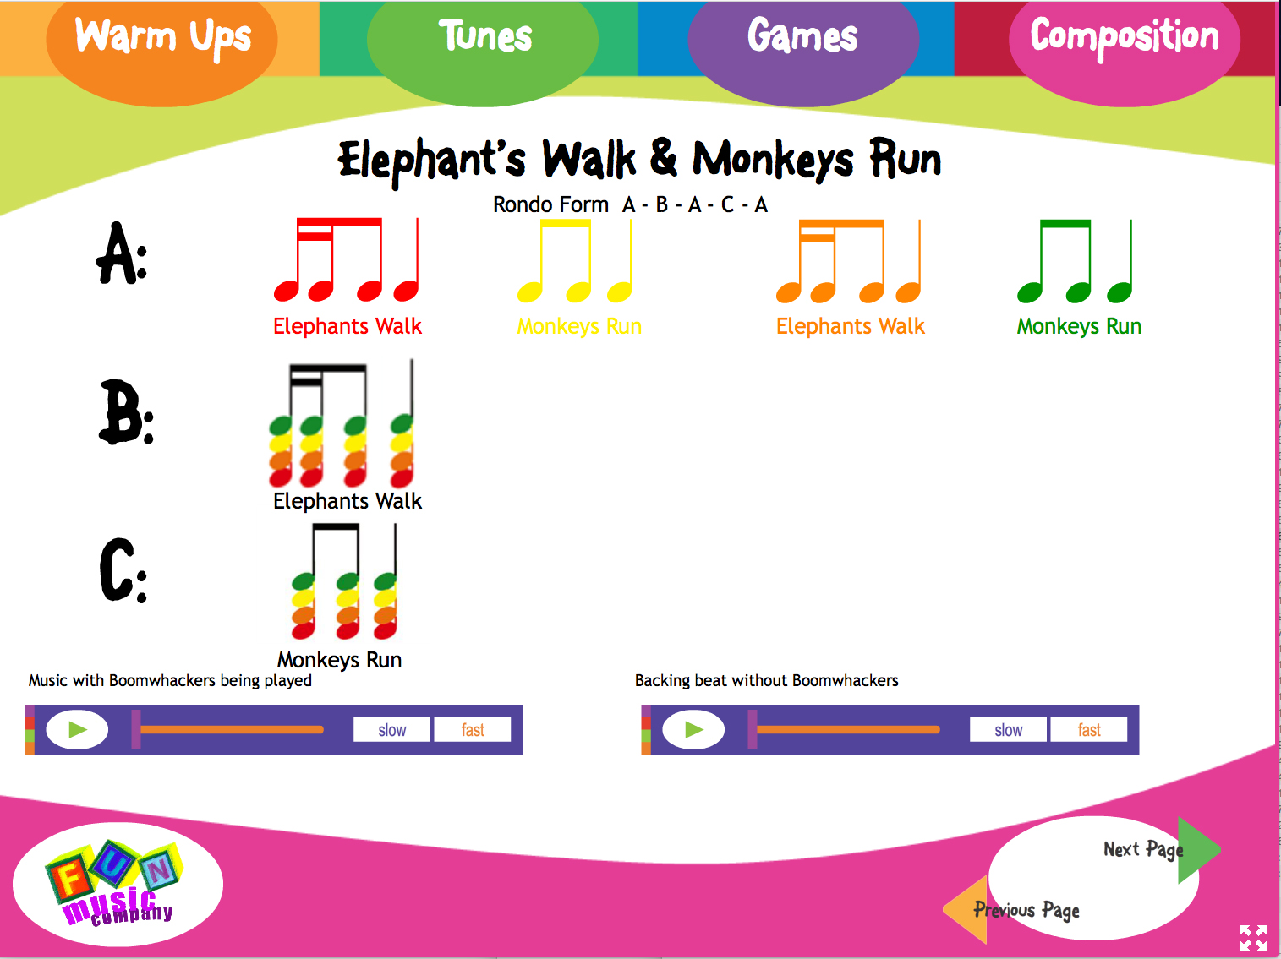
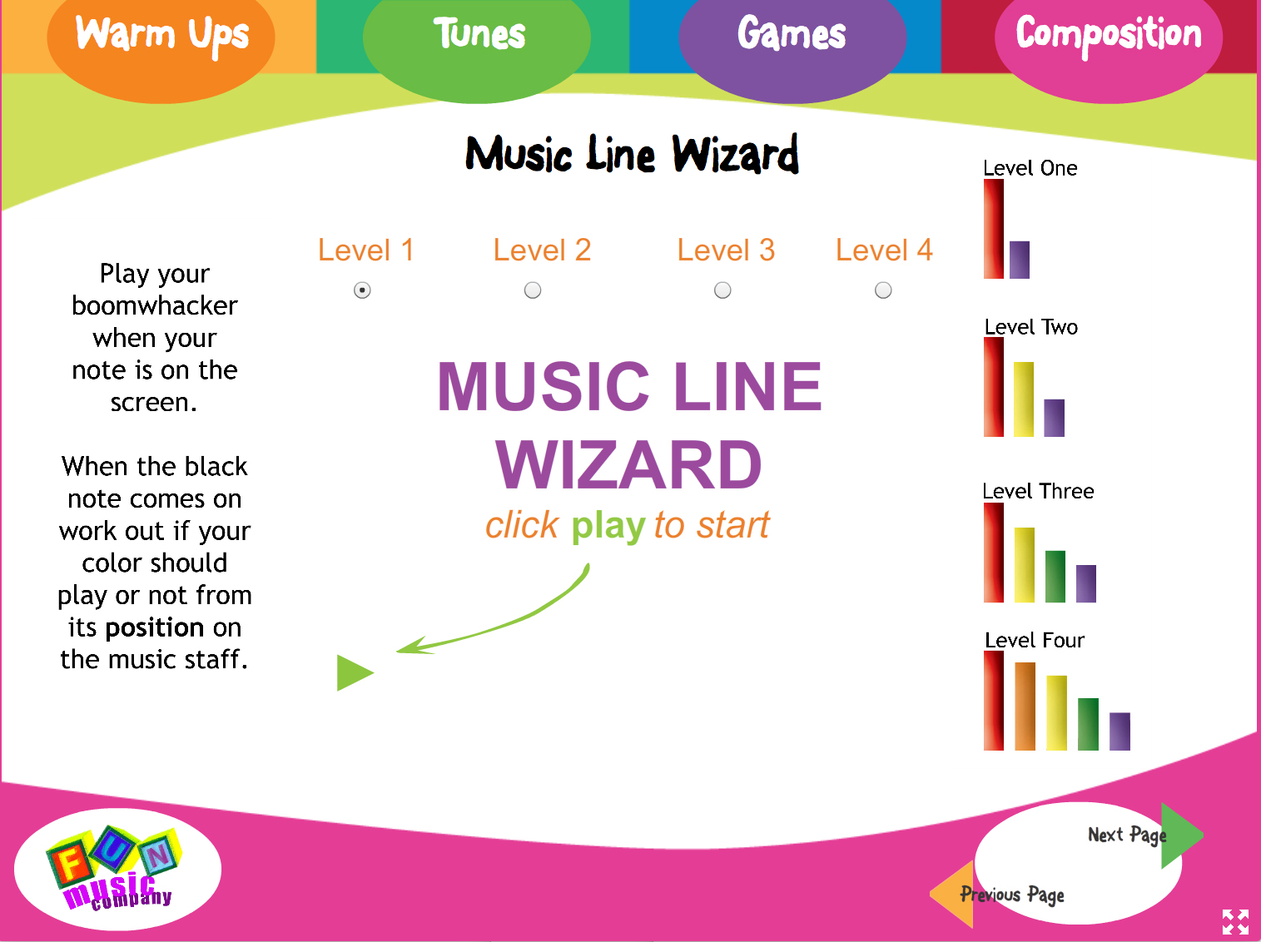
Screenshots:

Short Text:

In this fun and engaging CD-ROM children will learn a variety of musical concepts using Boomwhacker pitched percussion tubes.

Medium Text:

Have fun with Boomwhackers in the classroom! Using a projector or interactive whiteboard, the music teacher can get the class performing a song in no time at all using the fun Boomwhacker Beatz animations. There are ‘warmup songs’, based on easy to understand rhythms and pitch ideas, plus performance songs, composition activities and games.

Long Text:

Want to teach Boomwhackers in the Classroom but don’t know where to start?

Boomwhacker Beatz songs and games edition includes lots of activities for children to do with Boomwhackers in the classroom, even if they have had little or no music lessons before.

All you need is a whiteboard or projector hooked up to your computer, and you can play all the animations and games with the children, and they’ll have a wonderful time!

The program consists of four sections: warm ups, tunes, games and composition.

The warm ups are simple animations where the colourful ‘beatz’ characters jump around on the screen, and the children just have to play their Boomwhacker when their color appears. Its really easy, and lots of fun. Its also super flexible to work with whatever Boomwhackers you have available.

The tunes are actual pieces you can learn and perform with the children, while the games are designed to carefully teach essential musical skills through such games as the ‘mystery boomwhacker’ and the ‘music line wizard’.

In the composition section the children can actually make artistic choices about pitch, melody and rhythm and construct their own pieces

‘Boomwhacker Beatz’ Curriculum Edition Retail $79.95

UPC: 760999951140

Barcode on product:
This is a software DVD-ROM designed for use in elementary schools.
Compatible with PC or Mac.

Please note: This DVD-ROM contains much of the same content as ‘Boomwhacker Beatz songs and games’, but with additional content including complete lesson plans and customisable lessons in SMART Notebook and ActiveInspire formats. Customers should choose ONE of ‘songs and games edition’ OR ‘curriculum edition’

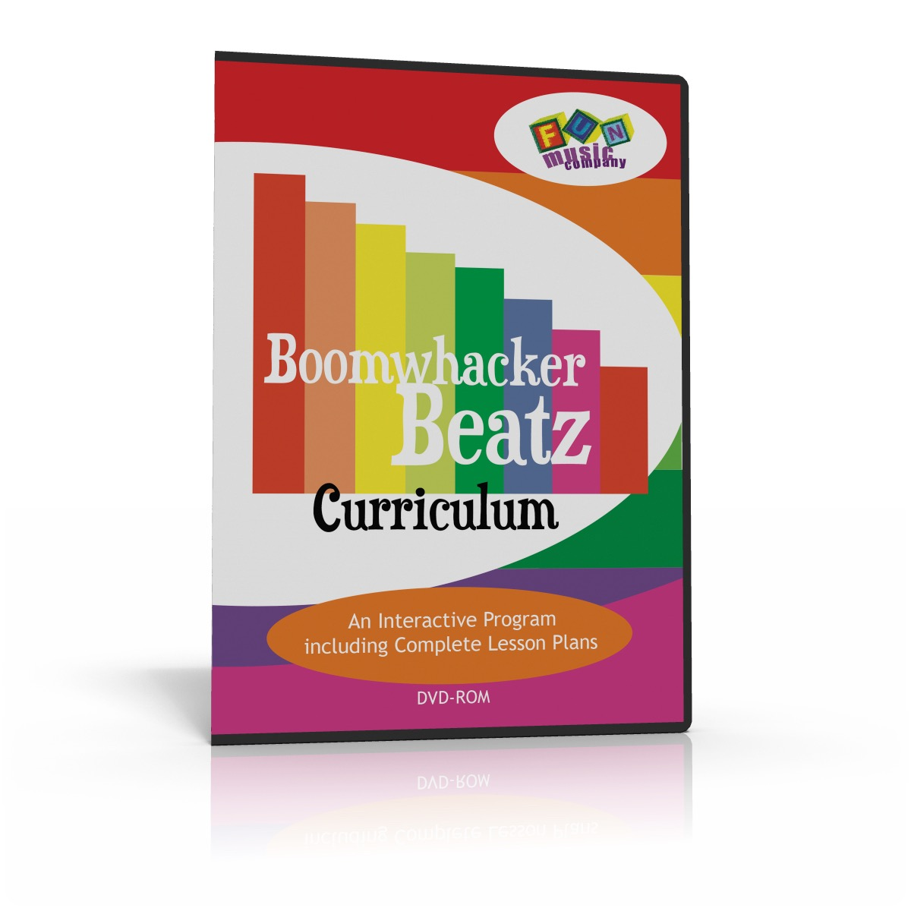

Lesson Plans:

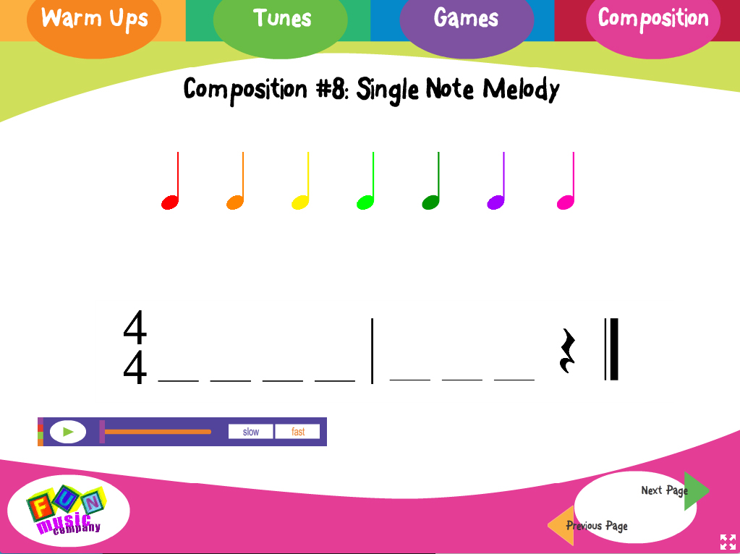
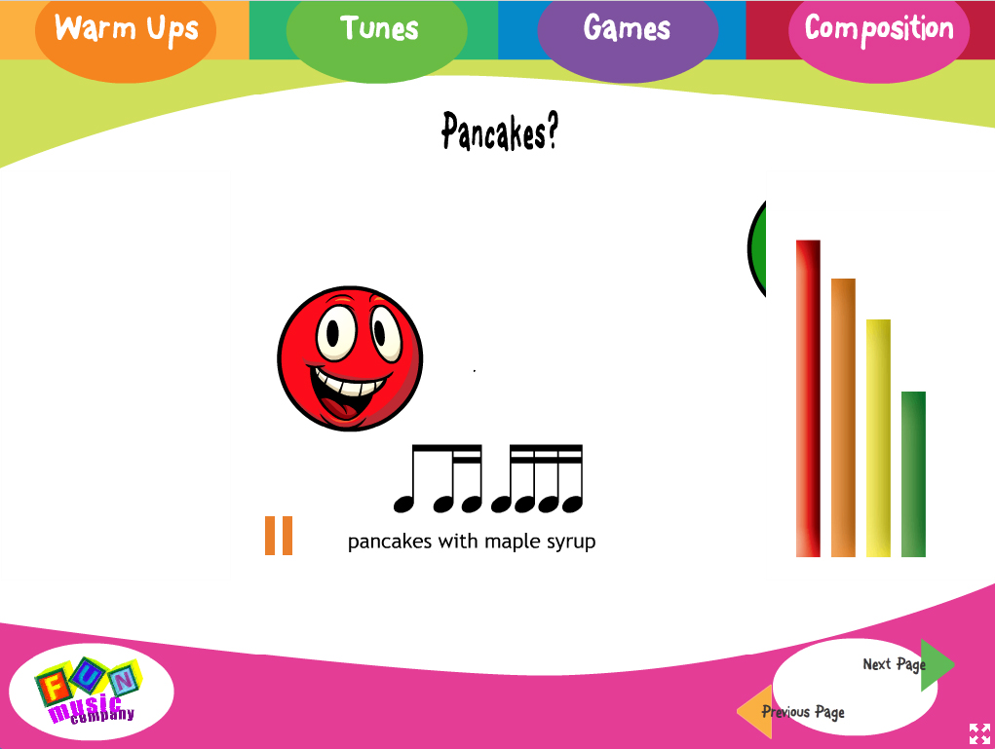
Screenshots:

Short Text:

In this software DVD package, teachers will have a full set of customisable lessons for teaching music with Boomwhacker pitched percussion tubes.

Medium Text:

Teach important musical concepts with Boomwhackers! This includes the complete whiteboard program as in ‘Boomwhacker Beatz songs and games’, plus more music theory and composition ideas. This has the stand-alone interface plus the lessons in a customisable interactive whiteboard format for SMARTNotebook and ActiveInspire, and step by step lesson plans, so that the teacher can use it for a complete unit of work.

Long Text:

Want to teach Boomwhackers in the music classroom?

Boomwhacker Beatz curriculum edition is a great choice for teachers who would like to use their Boomwhacker pitched percussion tubes for music lessons.

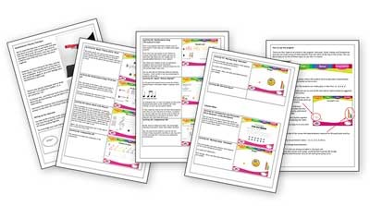
All you need is a whiteboard or projector hooked up to your computer, and you can play all the animations and games with the children, and they’ll have a wonderful time!

The core program consists of four sections: warm ups, tunes, games and composition.

The warmups are simple animation where the colourful ‘beatz’ characters jump around on the screen, and the children just have to play their Boomwhacker when their color appears. The tunes are actual pieces you can learn and perform with the children, while the games are designed to carefully teach essential musical skills through such games as the ‘mystery Boomwhacker’ and the ‘music line wizard’.

In the composition section the children can actually make artistic choices about pitch, melody and rhythm and construct their own pieces

In the expanded ‘curriculum edition’ there is also a comprehensive lesson plan document for ten lessons covering all aspects of music tuition, so teachers can use it for a complete unit of work.

